

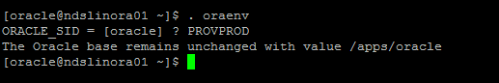

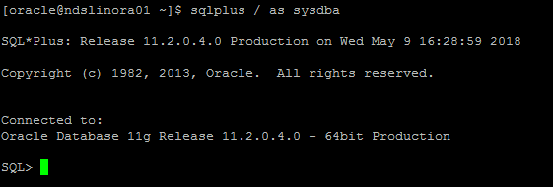

Select name,open_mode,database_role from v$database;

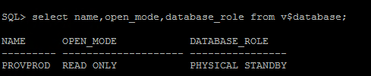

crontab –e

# to comment

Hit “I” to insert or “r” to replace or “dvi” to delete

:q or :wq (force it) to commit

:q! to exit without changes (ctrl c if this doesn’t work)

Highlight and right-click to copy commands if you want to run it

select max(sequence#) from v$log_history;

**cd /oradata/PROVPROD/arc01**

**ls -ltra**

Errors

Error: ORACLE not available

Fix: Type STARTUP from sqlplus